Ideation Phase
Empathize & Discover
Date | 31 January 2025
Team ID | __________
Project Name | LegalEase – AI-Powered Legal Document Generator
Maximum Marks | 4 Marks
Empathy Map Canvas
For LegalEase, the empathy map can focus on a typical user such as a startup founder, freelancer, landlord, or individual who needs to create a legal document without having extensive legal knowledge. These user scenarios are described in the project document.
👤 USER: Person Who Needs a Legal Document
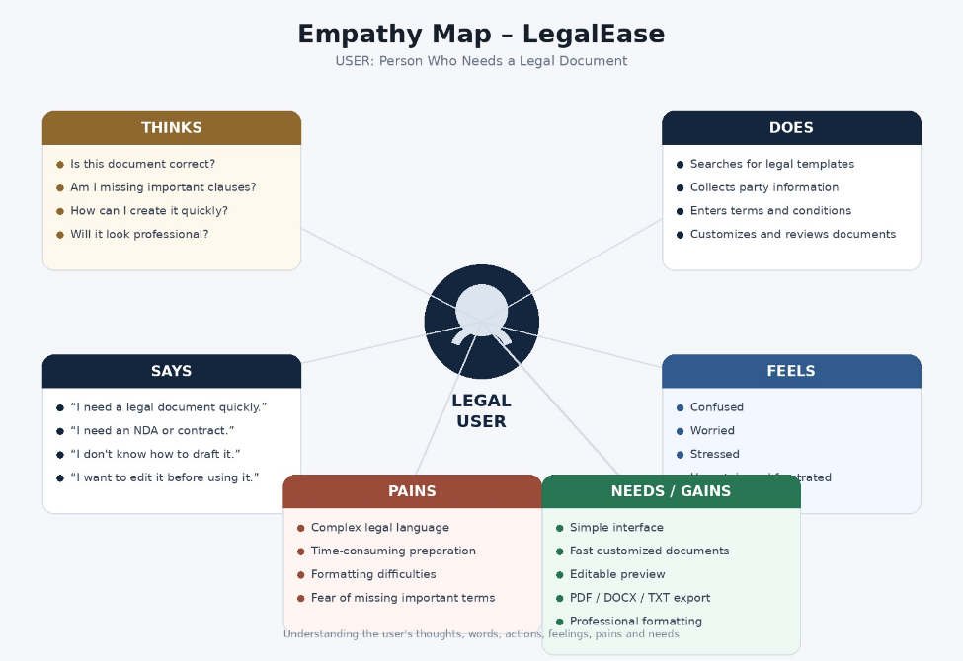

Empathy Map – Table Format
Says | Thinks
“I need a legal document quickly.” | “Is my document complete?”
“I need an NDA/contract/lease agreement.” | “Am I missing an important clause?”
“I don't know how to draft it.” | “How can I customize it for my situation?”
“I want to edit the document before using it.” | “Will the final document look professional?”

Does | Feels
Searches for legal templates | Confused
Collects information about the parties | Worried
Enters terms and conditions | Stressed
Tries to customize a document | Uncertain
Reviews the generated document | Frustrated

Pains | Needs / Gains
Complex legal language | Simple user interface
Time-consuming document preparation | Fast document generation
Difficulty selecting appropriate clauses | Customized document content
Formatting difficulties | Professional formatting
Concern about missing important terms | Editable document preview
Difficulty creating different document types | TXT, DOCX and PDF export
The project's documented requirements specifically include customizable legal documents, editable previews, professional formatting, and PDF/DOCX/TXT export, which support the needs identified above.
🎯 User Goal
“I want to create a professional, customized legal document easily, review it, edit it, and download it in a suitable format without needing extensive legal-document drafting knowledge.”

